# EVENT MANAGEMENT SYSTEM

A Mini Project Report submitted to Kakatiya University in partial fulfillment of minimum academic requirements for

## BACHELOR OF TECHNOLOGY IN

**COMPUTER SCIENCE AND ENGINEERING**

**Submitted By**

**R. Varun Guptha(214931028L)**

**Under the guidance of**

**Mr.V.Srujan**

**DEPARTMENTOFCOMPUTER SCIENCE ANDENGINEERING**

# CHAITANYAINSTITUTEOFTECHNOLOGY&SCIENCE

**HANAMKONDA,WARANGAL -506001**

Accredited by NAAC“B++”Grade

(Affiliated to Kakatiya University)

(2022-2023)

# CHAITANYAINSTITUTEOFTECHNOLOGY&SCIENCE

**HANAMKONDA, WARANGAL-506001**

**DEPARTMENT OF COMPUTER SCIENCE AND ENGINEERING**



**CERTIFICATE**

This is to certify that the industrial Training report entitled “EVENT MANAGEMENT SYSTEM**”**is being submitted by **R.Varun Guptha(214931028L)** in the partial fulfillment of the requirements for the award of the degree of **Bachelor of Technology** in “**Computer Science and Engineering**” at the **Kakatiya University** during the academic year2022-2023.

Name and Signature of Project Guide Name and Signature of HOD

(Mr.V.Srujan) (Prof. N. Satheesh Kumar)

Name and Signature of Principal

(Prof. G. SHANKARLINGAM)

**Signature of External examiner with Date**

# ACKNOWLEDGEMENT

The success accomplished in this project would not have been possible, by timely help and guid ancerendered by many people,we wish to express our since reand heartfelt gratitude to all those who have helped andguided us for the completion of the project.

We sincerely extend our thanks to,Department of Computer Science and Engineering for giving us moral support, kind attentionand valuable guidanceto us through out this training work.

We extent our heartfelt thanks to of the Department of Computer Science and Engineering forhisen couragement during the progress of this Industrial Training work.

We would like to express our deep sense of gratitude to **Dr. G. SHANKARLINGAM**, **Principal**, Chaitanya Institute of Technology and Science, for providing there quired facilitiesin the college campus.

We would also thank all the staff of department of electronics and communication engineering who has helped us directly or indirectly for the successful completion of the project.

Finally, we express our sincere thanks & gratitude to our family members & friends for their constant encouragement and moral support,which made the project successful.

**R.Varun Guptha(214931028L)**

# DECLARATION

We here submit that the mini project report entitled **“EVENT MANAGEMENT SYSTEM”** is an original work done at **Chaitanya Institute of Technology and Science, Hanamkonda** under the value able guidance of **GUIDE Mr.Srujan ,Department of Computer Science and Engineering,** inpartial fulfillment of there quirement for the award of the degree of **Bachelor of Technology** in Computer Science and Engineering.We here by declare that this project report be arsnoresemblance to any other report submitted at *Chaitanya Institute of Technology and Science* or any other college affiliated to Kakatiya University for the award of the degree.

**R.Varun Guptha(214931028L)**

**TABLE OF CONTENTS**

**CHAPTER 1**

**1.1 ABSTRACT ………………………………………………………………………………**

**1.2INTRODUCTION…………………………………………………………………………**

**1.3 SCOPE OF THE PROJECT…………………………………………………**

**1.4 FUNCTIONAL REQUIREMENT………………………………………………………**

**1.5 NON-FUNCTIONAL REQUIREMENT…………………………………………………**

**1.6 SOFTWARE REQUIREMENT…………………………………………………………**

**1.7 HARDWARE REQUIREMENT…………………………………………………………**

**CHAPTER 2 DESIGN**

**2.1 E.RDIAGRAM………………………………………………………………………………**

**2.2 ACTIVITYDIAGRAM………………………………………………………………………**

**2.3 SEQUENCEDIAGRAM……………………………………………………………………**

**2.4 USECASEDIAGRAM………………………………………………………………………**

**2.5 CLASSDIAGRAM……………………………………………………………………………**

**CHAPTER 3**

**3.1 OBJECTIVE………………………………………………………………………………**

**3.2 DESCRIPTION…………………………………………………………………………**

**CHAPTER 4**

**4.1 PROJECT CODE…………………………………………………………………………**

**4.2 SCREENSHORTS…………………………………………………………………………**

**43 TESTCASES………………………………………………………………………………**

**4.3 CONCLUSION……………………………………………………………………………**

**4.5 REFERENCES……………………………………………………………………………**

**CHAPTER 1**

**1.1 ABSTRACT**

The Event Management System is a robust and user-friendly mini-project designed to facilitate efficient event planning and execution. This web-based application aims to streamline the process of organizing diverse events, ranging from conferences, workshops, seminars, to social gatherings and corporate functions. The system incorporates an intuitive interface, enabling event organizers to manage tasks, resources, and attendees seamlessly.The Event Management System is designed to enhance event planning efficiency, reduce manual effort, and enhance overall event experiences for organizers and attendees alike. By employing this mini-project, individuals and organizations can successfully execute memorable events, fostering better engagement and satisfaction among participant

**1.2 INTRODUCTION**

Welcome to the world of Event Management System! Our mini project aims to provide an efficient and user-friendly platform for organizing, planning, and managing events of all kinds. Whether it's a corporate conference, a social gathering, a wedding, or any other event, our system is designed to streamline the entire event lifecycle.

In today's fast-paced world, managing events can be a daunting task, involving countless details, schedules, and communication with various stakeholders. The Event Management System is here to simplify this process, allowing event organizers to focus on creativity and engagement while leaving the administrative hassles to the software.It provides a seamless experience, making event management a breeze and allowing you to focus on creating memorable moments for all involed.

**1.3 SCOPE:**

The scope of an event management system can be quite extensive, as it involves various aspects of planning, organizing, and executing events of all scales.The system should support a wide range of event types, including corporate conferences, weddings, trade shows, music concerts, sports events, fundraisers, festivals, workshops, and more.The scope of an event management system can vary based on the specific needs of the organization or event planners. It's important to define the scope clearly before development to ensure the system meets all necessary requirements.

**1.4 FUNCTIONAL REQUIREMENTS:**

1.Gather event details such as event name, date, time, location, description, and type of event.

2.Provide organizers with insights to improve future events.

3.Implement an admin panel to manage events and perform necessary system configurations.

4.User can see the previous done events by our team.

**1.5 NON FUNCTIONAL REQUIREMENTS:**

1.User must not negotiate with the charge of an Event.

2.The system is compatible with various browsers, devices, and operating systems to cater to a diverse user base.

3.The system is scalable to accommodate increasing user and event data without requiring major architectural changes.

**1.6 SOFTWARE REQUIREMNETS:**

* Web Technologies : HTML, CSS, Bootstrap
* Scrippting Language : Javascript
* Data Base: My sql
* Operating System : Windows

**1.7 HARDWARE REQUIREMENTS:**

* RAM : 8 GB (further increase that as per requirement.)
* Display: 1024 * 768, True Type Color-32 Bit
* Hard Disk: 1 TB (further increase that as per requirement.)
* Mouse: Any Normal Mouse.
* Keyboard: Any window Supported Keyboard.

**CHAPTER -2**

**DESIGN**

**2.1 ER DIAGRAM:**

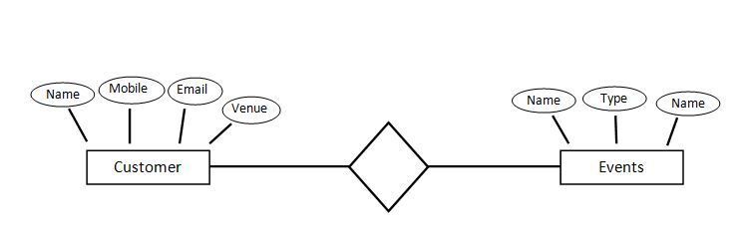

**2.2 ACTIVITY DIAGRAM:**

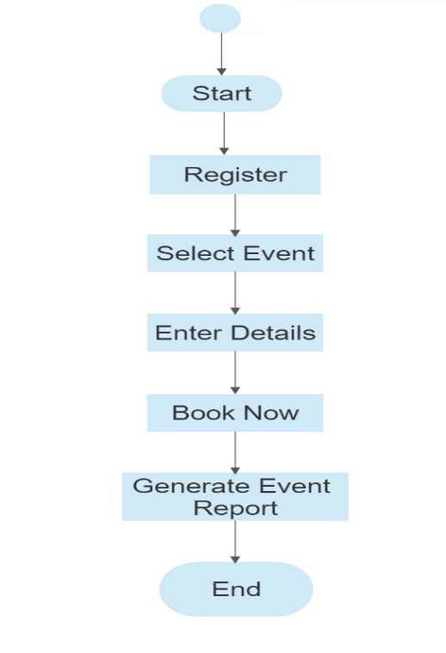

**2.3 SEQUENCE DIAGRAM:**

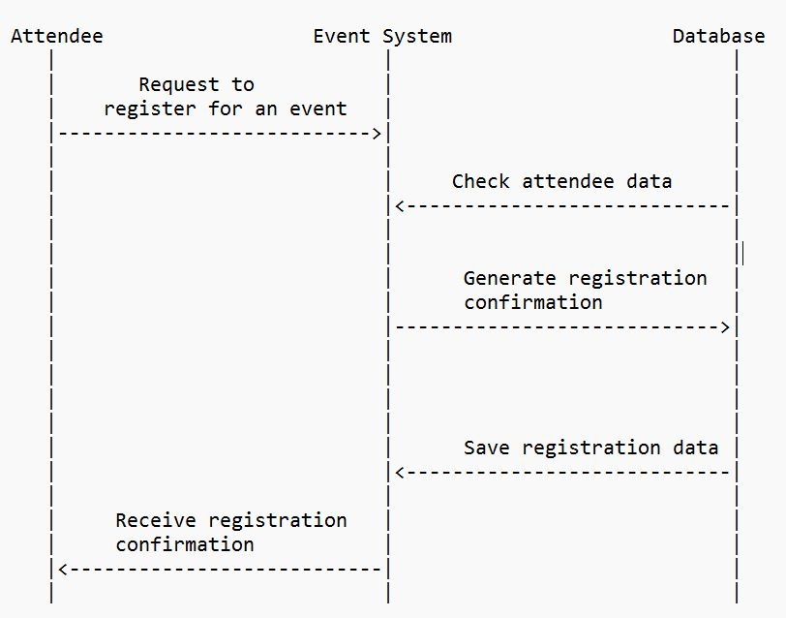

**2.4 USECASE DIAGRAM:**

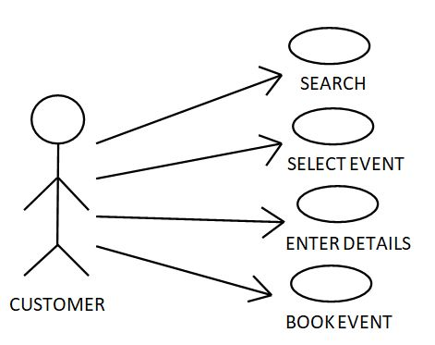

**2.5 CLASS DIAGRAM:**

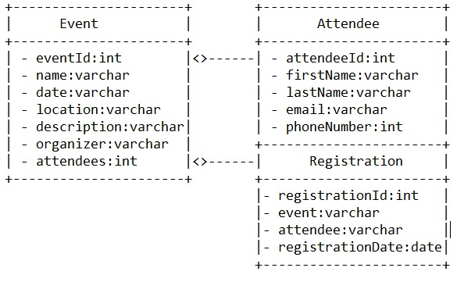

**CHAPTER 3**

**3.1 OBJECTIVE:**

The objective of an event management system is to efficiently plan, organize, and execute events while ensuring a seamless and memorable experience for all participants. An event management system aims to optimize the allocation of resources such as venues, equipment, staff, and other essential elements required to run a successful event. This ensures cost-effectiveness and maximizes the use of available resources. Overall, the primary objective of an event management system is to enhance efficiency, organization, and attendee experience throughout the entire event lifecycle, leading to successful and memorable events.

**3.2 DESCRIPTION:**

An Event Management System (EMS) is a sophisticated software solution designed to streamline and enhance the planning, organization, and execution of various types of events, from conferences and seminars to weddings and festivals. This comprehensive system offers a wide range of tools and features that enable event planners, organizers, and participants to collaborate seamlessly, ensuring the success of every event.

The Event Management System (EMS) is a user-friendly and intuitive platform that empowers event planners and organizers to efficiently manage every aspect of an event's lifecycle. From initial planning and promotion to registration, coordination, and post-event analysis, the EMS provides a centralized hub for all tasks and information related to the event.

**CHAPTER 4**

**4.1 PROJECT CODE:**

<!DOCTYPE html>

<html>

<head>

<meta name="viewport" content="width=device-width, initial-scale=1">

<link rel="stylesheet" href="https://stackpath.bootstrapcdn.com/bootstrap/4.5.2/css/bootstrap.min.css" integrity="sha384-JcKb8q3iqJ61gNV9KGb8thSsNjpSL0n8PARn9HuZOnIxN0hoP+VmmDGMN5t9UJ0Z" crossorigin="anonymous" />

<script src="https://code.jquery.com/jquery-3.5.1.slim.min.js" integrity="sha384-DfXdz2htPH0lsSSs5nCTpuj/zy4C+OGpamoFVy38MVBnE+IbbVYUew+OrCXaRkfj" crossorigin="anonymous"></script>

<script src="https://cdn.jsdelivr.net/npm/popper.js@1.16.1/dist/umd/popper.min.js" integrity="sha384-9/reFTGAW83EW2RDu2S0VKaIzap3H66lZH81PoYlFhbGU+6BZp6G7niu735Sk7lN" crossorigin="anonymous"></script>

<script src="https://stackpath.bootstrapcdn.com/bootstrap/4.5.2/js/bootstrap.min.js" integrity="sha384-B4gt1jrGC7Jh4AgTPSdUtOBvfO8shuf57BaghqFfPlYxofvL8/KUEfYiJOMMV+rV" crossorigin="anonymous"></script>

<script src="slider.js"></script>

</head>

<body>

<div id="section1">

<div class="sec1-main-bg d-flex flex-column justify-content-center">

<h1 class="sec4-head">Event Management System</h1>

<div class="sec1-card ">

<label class="labelh" onclick="display('section1')">Home</label>

<label class="labele" onclick="display('section2')">Events</label>

<label class="labelo" onclick="display('section6')">Our Gallery</label>

<label class="labela" onclick="display('section7')">About Us</label>

</div>

</div>

</div>

<div id="section2">

<div class="sec2-main-bg"><br><br>

<h1 class="sec1-head">Our Events</h1><br><br>

<div class="sec2-card d-flex flex-row" onclick="display('section3')">

<img src="https://cdn.discordapp.com/attachments/803924114112380929/1090643235828932769/hp_1.png" class="sec2-img"/>

<div class="sec2-content">

<h2 class="sec2-card-head">Birthday Party</h2>

<p class="sec2-para">We welcomed her with the birthday song and hugs from everyone. We all had an amazing time at the party.

Everybody socialized, we played party games, danced and had a lot of fun throughout the evening. The best part was the fact

that everyone was happy with the celebration and there were smiles all around me.</p>

</div>

</div>

<div class="sec2-card d-flex flex-row" onclick="display('section4')">

<img src="https://cdn.discordapp.com/attachments/803924114112380929/1090643235086540920/fp.png" class="sec2-img" />

<div class="sec2-content">

<h3 class="sec2-card-head">Fresher's Party</h3>

<p class="sec2-para">Freshers week is one of the most talked about times in a student's first year at university. From creating

hangovers from hell to friends for a lifetime, it can be one of the most memorable times for a new student.</p>

</div>

</div>

<div class="sec2-card d-flex flex-row" onclick="display('section5')">

<img src="https://cdn.discordapp.com/attachments/803924114112380929/1090643235468230776/ha.png" class="sec2-img" />

<div class="sec2-content">

<h4 class="sec2-card-head">Anniversary</h4>

<p class="sec2-para">An anniversary is the date on which an event took place or an institution was founded in a previous year,

and may also refer to the commemoration or celebration of that event.5</p>

</div>

</div>

<button class="buttonb" onclick="display('section1')">Back</button>

</div>

</div>

<div id="section3">

<div class="center-form"><b><font color="black"></font>

<h2 style="color: #000000"><b><u>Event Booking Form:</b></u></h2>

<form action="" method="post">

<label for="name">Name:</label>

<input type="text" id="name" name="name" required><br><br>

<label for="email">Email:</label>

<input type="email" id="email" name="email" required><br><br>

<label for="phone">Phone:</label>

<input type="tel" id="phone" name="phone" required><br><br>

<label>Select your Event: </label>

<select>

<option value = "BP">Birthday Party</option>

<option value = "FP">Freshers Party</option>

<option value = "AY">Anniversary</option>

</select><br><br>

<label for="venue">Venue:</label>

<input type="text" id="venue" name="venue"required><br><br>

<label for="date">Date:</label>

<input type="date" id="date" name="date" required><br><br>

<label for="guests">Number of Guests:</label>

<input type="number" id="guests" name="guests" required><br><br>

<label type="services">Additional Services:</label><br>

<input type="checkbox" id="Service1" name="Service1" value="Service">

<label for="service1"> Catering</label><br>

<input type="checkbox" id="service2" name="service2" value="Service">

<label for="service2">Wallet Parking</label><br>

<input type="checkbox" id="service3" name="service3" value="Service">

<label for="service3">Dancing Event</label><br>

<input type="checkbox" id="service4" name="service4" value="Service">

<label for="service4">Singing Event</label><br>

</form>

<button class="button2">Book Now</button>

<button class="buttonb" onclick="display('section2')">Back</button></b>

<button class="buttonh3" onclick="display('section1')">Home</button>

</div>

</div>

<div id="section4">

<div class="center-form"><b><font color="black"></font>

<h2 style="color: #000000"><b><u>Event Booking Form:</b></u></h2>

<form action="" method="post">

<label for="name">Name:</label>

<input type="text" id="name" name="name" required><br><br>

<label for="email">Email:</label>

<input type="email" id="email" name="email" required><br><br>

<label for="phone">Phone:</label>

<input type="tel" id="phone" name="phone" required><br><br>

<label>Select your Event: </label>

<select>

<option value = "FP">Freshers Party</option>

<option value = "BP">Birthday Party</option>

<option value = "AY">Anniversary</option>

</select><br><br>

<label for="venue">Venue:</label>

<input type="text" id="venue" name="venue"required><br><br>

<label for="date">Date:</label>

<input type="date" id="date" name="date" required><br><br>

<label for="guests">Number of Guests:</label>

<input type="number" id="guests" name="guests" required><br><br>

<label type="services">Additional Services:</label><br>

<input type="checkbox" id="Service1" name="Service1" value="Service">

<label for="service1"> Catering</label><br>

<input type="checkbox" id="service2" name="service2" value="Service">

<label for="service2">Wallet Parking</label><br>

<input type="checkbox" id="service3" name="service3" value="Service">

<label for="service3">Dancing Event</label><br>

<input type="checkbox" id="service4" name="service4" value="Service">

<label for="service4">Singing Event</label><br>

</form>

<button class="button2">Book Now</button>

<button class="buttonb" onclick="display('section2')">Back</button></b>

<button class="buttonh3" onclick="display('section1')">Home</button>

</div>

</div>

<div id="section5">

<div class="center-form"><b><font color="black"></font>

<h2 style="color: #000000"><b><u>Event Booking Form:</b></u></h2>

<form action="" method="post">

<label for="name">Name:</label>

<input type="text" id="name" name="name" required><br><br>

<label for="email">Email:</label>

<input type="email" id="email" name="email" required><br><br>

<label for="phone">Phone:</label>

<input type="tel" id="phone" name="phone" required><br><br>

<label>Select your Event: </label>

<select>

<option value = "AY">Anniversary</option>

<option value = "BP">Birthday Party</option>

<option value = "FP">Freshers Party</option>

</select><br><br>

<label for="venue">Venue:</label>

<input type="text" id="venue" name="venue"required><br><br>

<label for="date">Date:</label>

<input type="date" id="date" name="date" required><br><br>

<label for="guests">Number of Guests:</label>

<input type="number" id="guests" name="guests" required><br><br>

<label type="services">Additional Services:</label><br>

<input type="checkbox" id="Service1" name="Service1" value="Service">

<label for="service1"> Catering</label><br>

<input type="checkbox" id="service2" name="service2" value="Service">

<label for="service2">Wallet Parking</label><br>

<input type="checkbox" id="service3" name="service3" value="Service">

<label for="service3">Dancing Event</label><br>

<input type="checkbox" id="service4" name="service4" value="Service">

<label for="service4">Singing Event</label><br>

</form>

<button class="button2">Book Now</button>

<button class="buttonb" onclick="display('section2')">Back</button></b>

<button class="buttonh3" onclick="display('section1')">Home</button>

</div>

</div>

<div id="section6">

<div class="sec4-card-head">

<div class="sec4-main-bg">

<h2 class="sec4-head">Our Gallery</h2>

<div class="sec4-card d-flex flex-row" onclick="display('section1')"></div>

<div class="gallery">

<a target="_blank" href="https://cdn.discordapp.com/attachments/803924114112380929/1094991798482522183/ff.jpg">

<img src="https://cdn.discordapp.com/attachments/803924114112380929/1094991798482522183/ff.jpg" alt="birthday party image" width="3000px" height="1000px">

</a>

<div class="desc">Our Sample Event pics of Birthday Party.</div>

</div>

<div class="gallery">

<a target="_blank" href="https://cdn.discordapp.com/attachments/803924114112380929/1096428297925177434/140864088_686742181971290_1471508943793285657_n.png">

<img src="https://cdn.discordapp.com/attachments/803924114112380929/1096428297925177434/140864088_686742181971290_1471508943793285657_n.png" alt="Freshers party image" width="600" height="400">

</a>

<div class="desc">Our Sample Event pics of Fresher's Party.</div>

</div>

<div class="gallery">

<a target="_blank" href="https://cdn.discordapp.com/attachments/803924114112380929/1096430060778561616/1604991287_small.png">

<img src="https://cdn.discordapp.com/attachments/803924114112380929/1096430060778561616/1604991287_small.png" alt="Northern Lights" width="600" height="400">

</a>

<div class="desc">Our Sample Event pics of Anniversary.</div>

</div><br><br>

<button class="buttonb" onclick="display('section1')">Back</button>

</div></div></div>

<div id="section7">

<div class="about-section">

<h2>About Us</h2><br>

<p>Learn more about EventBooking and our mission to improve

the lives of venue professionals around the world.</p>

<footer>

<p>Developed By: Varun and Team .<br>

<a href="mailto:hege@example.com">samplemail@gmail.com</a></p>

<p>Our Mobile Number : <a href="mobilenumber">6309269814</a></p>

</footer><br><br>

<button class="buttonab" onclick="display('section1')">Back</button>

</div>

</div></div>

<script type="text/javascript" src="https://d1tgh8fmlzexmh.cloudfront.net/ccbp-static-website/js/ccbp-ui-kit.js"></script>

</body>

</html>

**4.2 Screen shots:**

**1. Homepage:**

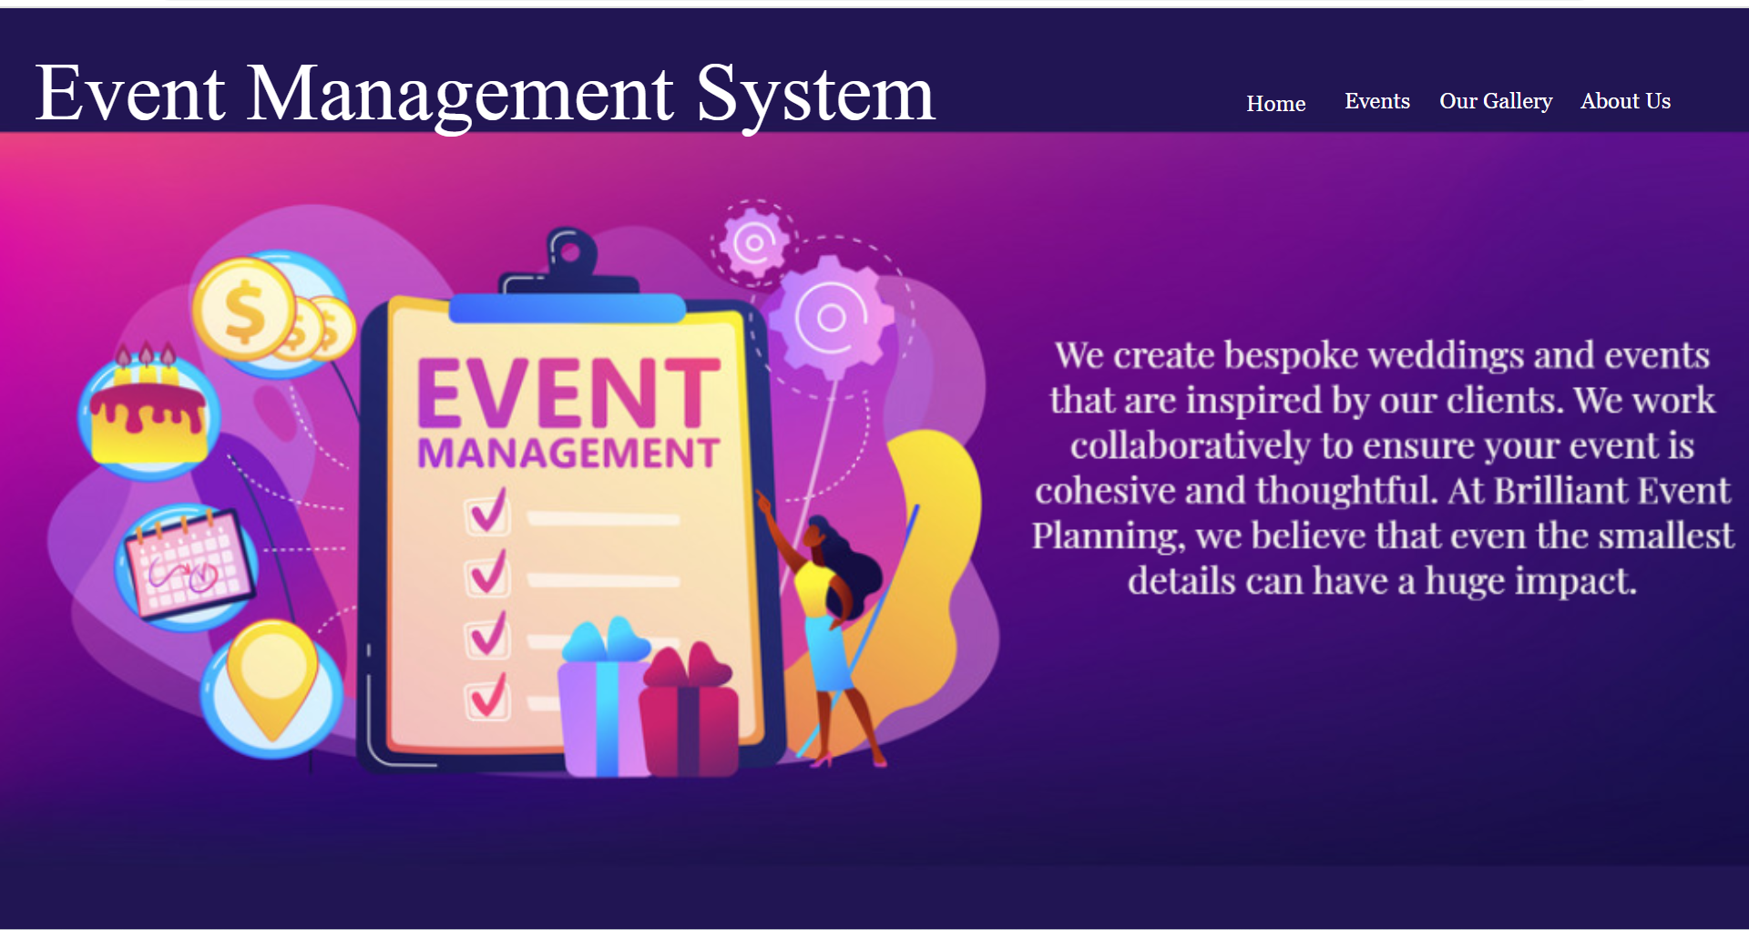

**2. Events Page :**

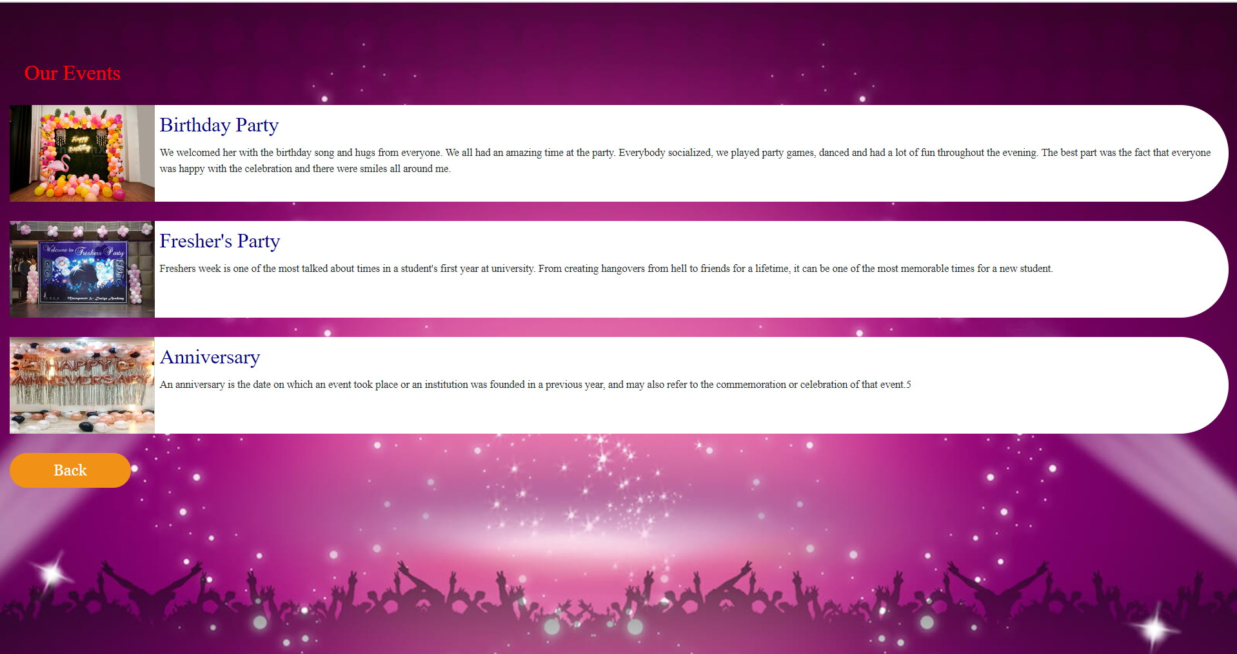

**3. Event Booking Form:**

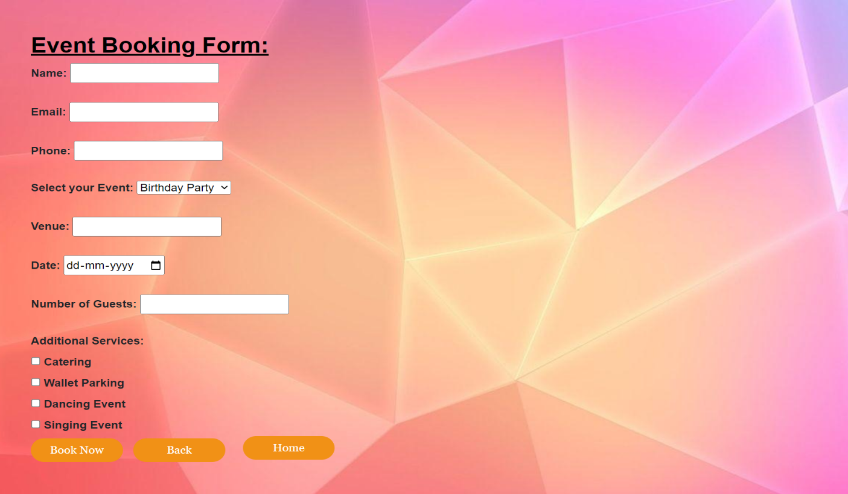

**4. Gallery :**

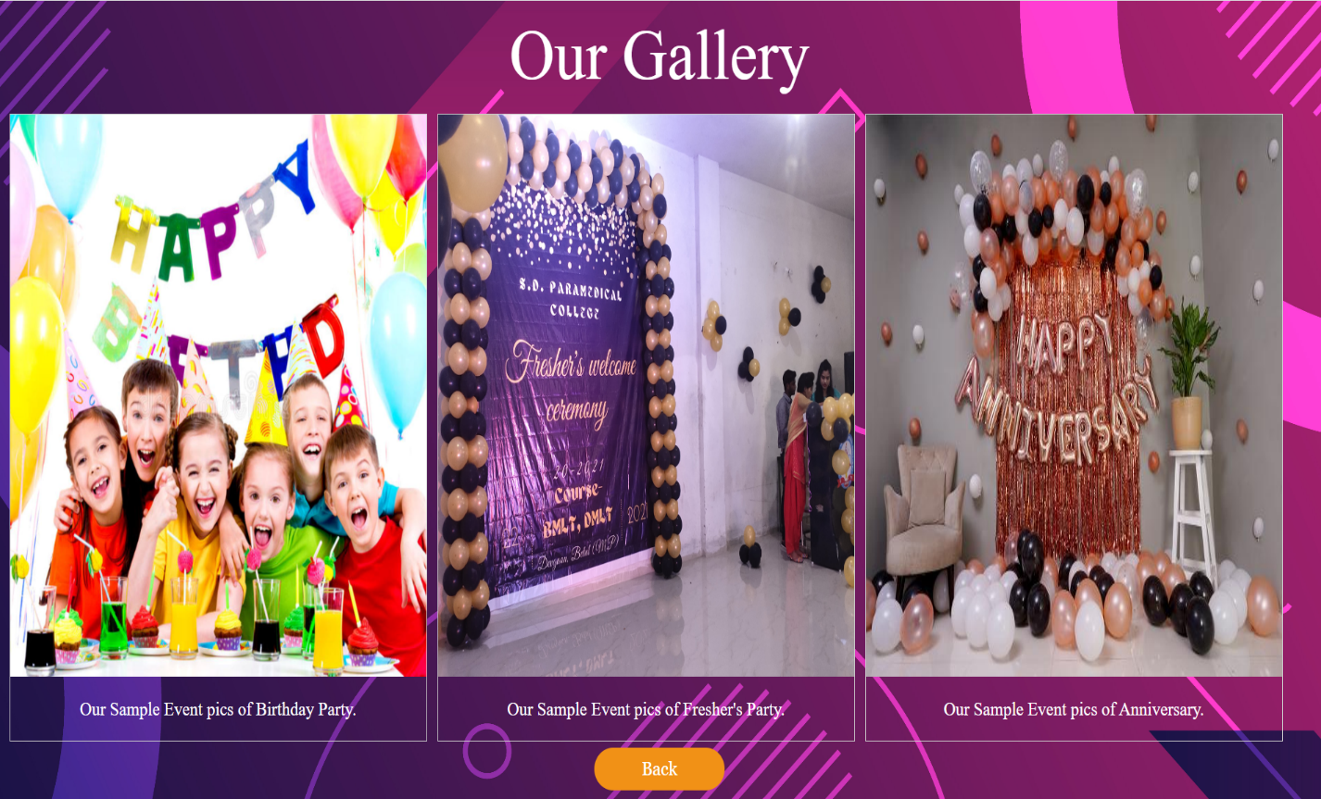

**5. About Us:**

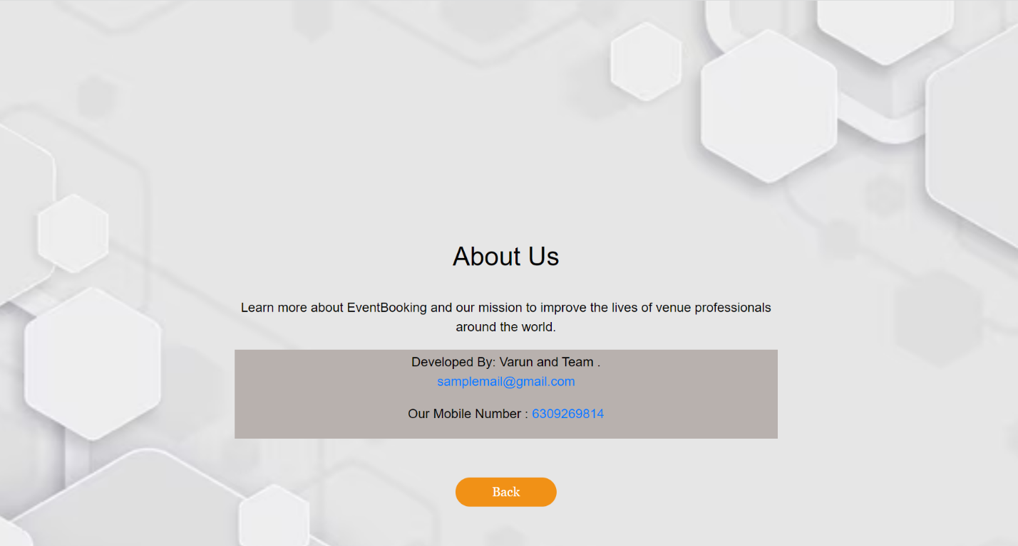

**4.3 Test Cases:**

|  |  |  |  |  |
| --- | --- | --- | --- | --- |
| Test Case ID | Description | Actual Output | Expected Output | Result |
| 01 | Create a new event with missing mandatory details | Error message: "Please fill in all required fields" | Error message: "Please fill in all required fields" | PASS |
| 02 | Register for an event with missing mandatory details | Error message: "Please provide all required information" | Error message: "Please provide all required information" | PASS |
| 03 | Register for an event with invalid participant details | Error message: "Invalid participant information" | Error message: "Invalid participant information" | PASS |
| 04 | Generate a report of registered attendees | Report is generated and displayed | Report is generated and displayed | PASS |

**4.4 Conclusion:**

It has been a great pleasure for me to work on this exciting and challenging project. The event management system has proven to be an invaluable tool in streamlining and enhancing the planning, organization, and execution of events. The event management system has revolutionized the way events are planned and executed. Its impact on efficiency, user experience, data utilization, communication, security, and cost-effectiveness makes it an indispensable tool for event professionals. With continuous improvements and updates, the system is poised to further enhance the event management landscape and create memorable experiences for attendees worldwide. This will provide better opportunities and guidance in future in developing projects independently.

**4.5 References:**

* Bizzabo is an all-in-one event management platform that helps organizers create engaging experiences and manage every aspect of their events.
* Website: <https://www.bizzabo.com/>
* Event Management and Marketing: Theory, Practical Approaches and Planning [Paperback] Dr. Anukrati Sharma and Dr. Shruti Arora Paperback – Illustrated, 1 January 2018